CO 2 – ASSESSMENT TOOL -2
COURSE CODE: DSA0308
COURSE NAME: NLP
Reg no:192425108 Name: K.Sadiq hussain

Q1. Morphological processing: analyzing, analysis, analytical
Aim: Identify roots and affixes, classify inflectional and derivational forms, and normalize related words for search engine indexing.
Python program:

words = ["analyzing", "analysis", "analytical"]

morphology = {
"analyzing": {
"root": "analyze",
"prefix": "None",
"suffix": "-ing",
"type": "Inflectional",
"normalized": "analyze"
},
"analysis": {
"root": "analy",
"prefix": "None",
"suffix": "-sis",
"type": "Derivational (irregular form)",
"normalized": "analyze"
},
"analytical": {
"root": "analysis",
"prefix": "None",
"suffix": "-ical",
"type": "Derivational",
"normalized": "analyze"
}
}

print(f"{'Word':<15}{'Root':<15}{'Suffix':<12}"
f"{'Type':<30}{'Normalized'}")

for word in words:
item = morphology[word]
print(f"{word:<15}{item['root']:<15}"
f"{item['suffix']:<12}{item['type']:<30}"
f"{item['normalized']}")

OUTPUT:
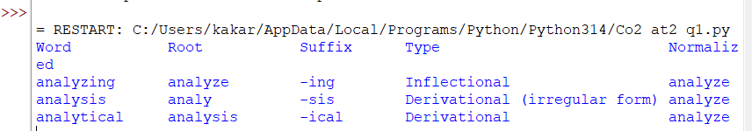

Q2. Morphological parsing: disagree, agreement, agreeable
Aim: Identify prefixes, roots, suffixes, derivational types, and semantic changes for sentiment analysis.
Python program:

words = ["disagree", "agreement", "agreeable"]

morphology = {
"disagree": {
"prefix": "dis-",
"root": "agree",
"suffix": "None",
"type": "Prefix derivation",
"meaning": "To have a different or opposing opinion",
"normalized": "agree"
},
"agreement": {
"prefix": "None",
"root": "agree",
"suffix": "-ment",
"type": "Derivational",
"meaning": "The state or result of agreeing",
"normalized": "agree"
},
"agreeable": {
"prefix": "None",
"root": "agree",
"suffix": "-able",
"type": "Derivational",
"meaning": "Pleasant or acceptable",
"normalized": "agree"
}
}

print(f"{'Word':<15}{'Prefix':<10}{'Root':<10}"
f"{'Suffix':<10}{'Type':<22}{'Normalized'}")

for word in words:
item = morphology[word]
print(f"{word:<15}{item['prefix']:<10}"
f"{item['root']:<10}{item['suffix']:<10}"
f"{item['type']:<22}{item['normalized']}")

print("Meaning:", item["meaning"])

OUTPUT:
